**Data Flow Diagram (DFD) for Retail App**

**Level 0 - Context Diagram**

At the highest level, the retail app is represented as a single process interacting with external entities.

**Diagram Representation:**

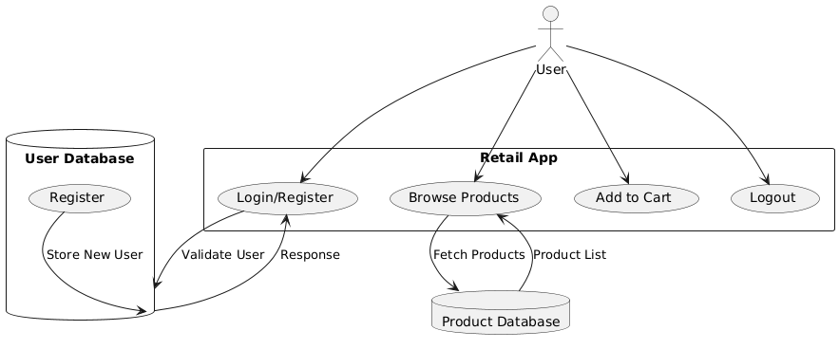

**Explanation:**

* **External Entity (User):** Interacts with the retail app.
* **Process (Retail App - 1.0):** Handles user authentication, product display, cart management, and order processing.
* **Data Store (User DB):** Stores user credentials and account details.
* **Data Store (Product DB):** Stores available product details.

**Level 1 DFD - Detailed Decomposition**

**Diagram Representation:** 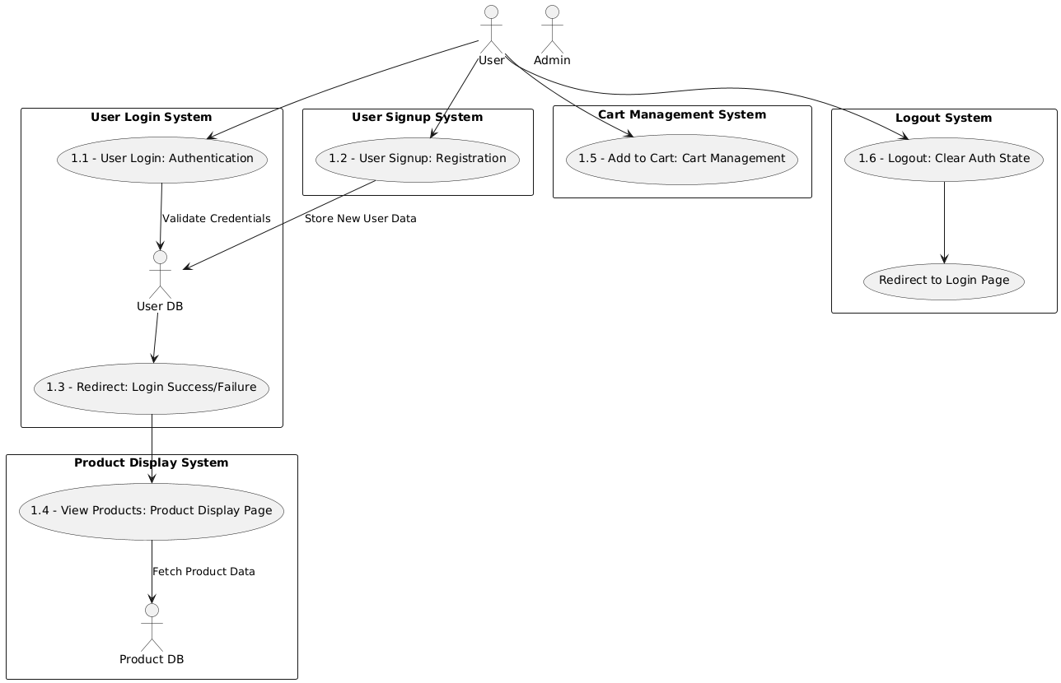

**Explanation:**

1. **Process 1.1 (User Login):** User enters credentials, which are validated against the **User DB**.
2. **Process 1.2 (User Signup):** New users register, and their details are stored in the **User DB**.
3. **Process 1.3 (Redirect):** If login is successful, the user is redirected to the **Retail Page**; otherwise, an error message is shown.
4. **Process 1.4 (View Products):** The product data is fetched from the **Product DB** and displayed.
5. **Process 1.5 (Add to Cart):** Users add items to the cart, which updates the cart state.
6. **Process 1.6 (Logout):** The authentication state is cleared, and the user is redirected to the login page.

**Data Flow:**

* Users enter login credentials → **Validated against User DB** → Success → Redirected to Retail Page.
* Users sign up → **Data stored in User DB**.
* Product data is fetched from **Product DB** and displayed.
* Users add products to the cart (temporarily stored in session state).
* Users log out → **Authentication state reset** → Redirected to login page.

**Conclusion**

The **Retail App DFD** illustrates how data flows through the system, showing user authentication, product management, cart interactions, and logout processes. This breakdown helps developers understand system interactions, data dependencies, and workflow efficiency.